Collab Project

Locator Service Implementation Information

Version <1.0>

Revision History
Date | Version | Description | Author
04/12/01 2:34 PM | 1.0 | Document Creation | Karl Fankhauser

Table of Contents
1. Introduction 4
1.1 Purpose of Locator Service 4
1.2 Scope of Locator Service 4
1.3 Operational Options 5
1.4 Overview of Locator Service Function 6
2. Three Phases of Lookup 6
3. Integration Options with Locator Service 8
3.1 Customer’s CDR solution integrated with CareScience Locator Service 8
4. Customer Web Application Requirements 8
4.1 Constraints 9
4.2 Parameters Passed to Web Application 9
4.3 Security 9
5. Locator Service Properties File 9
5.1 Property Hierarchy 10
5.2 Registering the Application System with Locator Service 10
5.2.1 Registering the type of information with the Locator Service 10
5.3 Registering Web Applications 10
5.4 Setting up Locator Service Operational Parameters 10
6. Integration Options 11
6.1 Locator Service Java Interface 11
6.1.1 Description 11
Definition 11
6.1.3 Registration with Properties file 11
6.2 Locator Service HL7 Definition 12
6.2.1 QRY Format 12
6.2.2 RSP format 13
6.2.3 Properties for HL7 interface 13
6.3 Locator Service HTTPS Post of Locator Information 13
6.3.1 DTD for messages 14
6.3.2 HTTP Post of Message 14
6.3.3 Properties for HTTP Post Interface 14
6.4 Future Options 14
7. Locator Service Client 14
8. Properties File DTD 16

Locator Service Implementation Information

Introduction
The CareScience Locator Service is a technology to enable Collaborative Computing between providers. By Collaborative Computing we refer to a set of technologies that allow distributed organizations to share resources and information via some network connectivity – in this case the Internet. The appearance of a single system is maintained to the user who can find and access the information stored with their trading partners according to the applicable information sharing agreements.
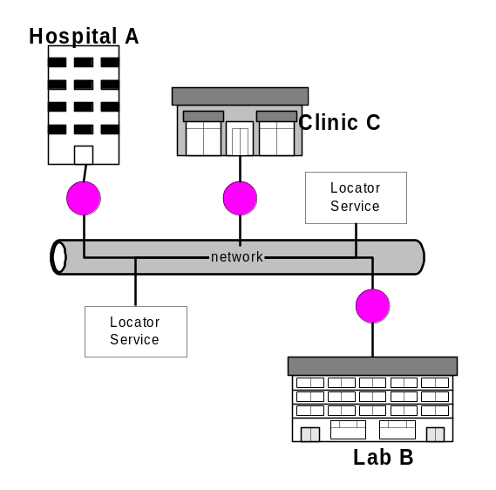The Locator Service promotes and supports a Network Centric, Distributed Architecture as seen in Figure 1. This diagram highlights the multiple points of entry into what becomes a network of services. These services include web servers that can supply the detailed clinical records in XML, HTML, or image formats to browsers located throughout different organizations. Multiple Locator Services coordinate the search for information that is of value to the provider at the point of care.
Figure 1 – Distributed Nature of Locator Service

Purpose of Locator Service
CareScience provides a (currently) ASP based service called the Universal Correlation System (UCS) that identifies where a Person has been treated by a health care provider. The Locator Service uses the information about where a person has been treated to find what information is available for that patient. The what is described as a locator that may be a URI, a manual location or an EDI interface. The Locator Service acts as a highly sophisticated search engine to find appropriate information that is of interest to the health care provider. In addition to the UCS the Locator Service also works with and Access Decision Service to determine what information can be returned to the calling physician.

Scope of Locator Service
The Locator Service provides the infrastructure necessary to determine what information is available, including the distributed processing, lookup and discovery services necessary to complete this step. The Locator Service does NOT store detailed clinical information. The Locator Service by itself does not attempt to actually display the clinical information. The Locator Service is not a “clearing house” type of technology.
The Locator Service allows the provider to specify various parameters to constrain the search for information. These parameters include the patient ID, a specific organization or domain that they wish to search within, the type and/or class of a datum and a date range. The specific date of the datum is returned along with the information needed to access the datum – typically a URL. A list of locators may be returned by a search. Clicking on a URL locator will navigate the user to a web application hosted by a remote organization that provides a web interface to the clinical information. The Locator Service does NOT return the actual clinical data, nor does its store this information.
The Locator Service can operate in one of three modes – as a “black box” service incorporated with a CareScience back end clinical repository hosted by CareScience. Optionally, the black box may be operated within a provider’s site. Finally, the Locator Service can integrated with an existing web-enabled data repository.
In order to provide the search and lookup capabilities, the Locator Service Three methods of integration with an existing.

Operational Options
There are three options for operating the locator service. First, the system can be operated as an ASP application hosted by CareScience. Second, the system can be operated by using the CareScience Clinical Data Repository (CDR). In this option, the locator service comes fully integrated with the CDR. Finally, the Locator Service can be integrated with a customer’s existing web enabled clinical repository (Figure 2).
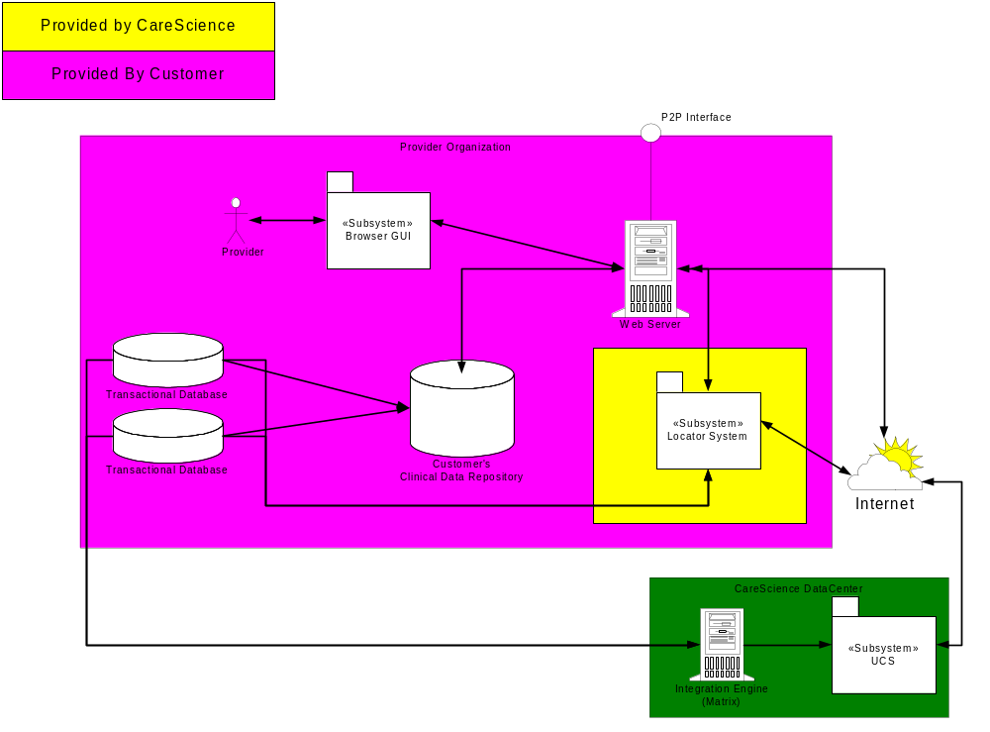
Figure 2 - Integration Option with Customer's CDR

Overview of Locator Service Function
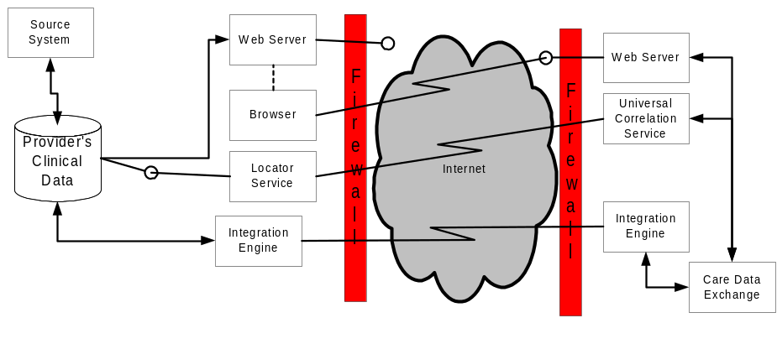The Locator service works in conjunction with the provider organization’s clinical data store, a web application that serves clinical information to potential information trading partners. Additionally, the system works with the Universal Correlation Service hosted by CareScience. The organization’s integration engine feeds patient demographic data to the correlation system. The locator service is a distributed, collaborative application. Each participant operates their own locator service typically behind his or her firewall.
Figure 3 Locator Service

Three Phases of Lookup
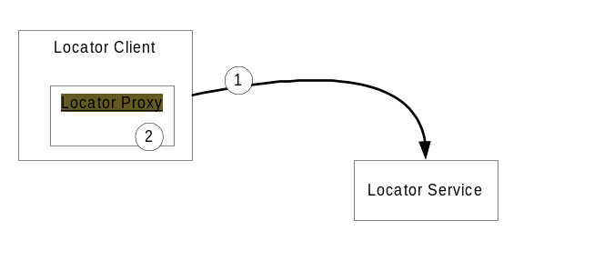The lookup of locator information can be described in three phases. The first phase of the lookup is relatively simple as seen below in Figure 4:

Figure 4 - Phase 1 of Locator Discovery
In step 1, a locator client performs discovery of locator services and connects to an associated locator service. The client downloads the proxy object in step 2. The client communicates the search parameters to the proxy (e.g. patient, provider, type, class, date range) and this information is passed to the service. The locator can now begin the next phase of the lookup process (Figure 5).

In the second phase, the locator uses information from the UCS about where a patient has been identified to perform a unicast query to each of the locator services running at the remote domains (Step 3).
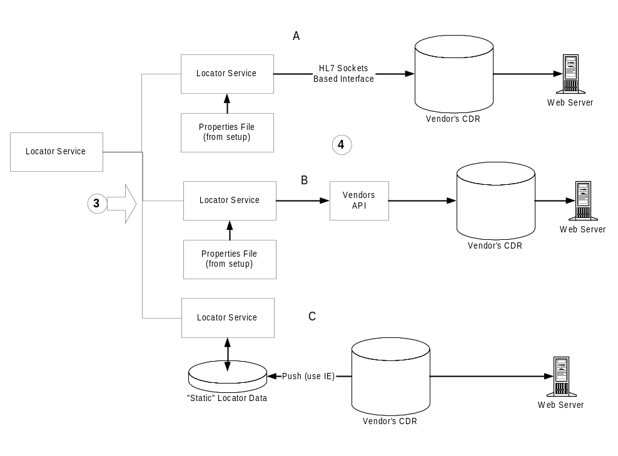Figure 5 - Phase 2 of Locator Discovery
In step 4, the locator service generates the list of locator information that will be returned. There are three options (below, Integration Options with Locator Service), for dealing with the information necessary to return a URI pointing to the clinical information. The options are, from top to bottom:
- Generating a query and submitting it via a standard HL7 interface – using QRY or QBP.
- Integrating the Locator service with an API implemented by the vendor or organization to get this information.
- Having the CDR system publish this information to our service, which would store the locators “statically”. This method would require add, update and delete functionality in the locator service to keep these locators up to date.
The parameter file that is read is used to store the templates describing the URL – the host name, port, file name and parameters that make up the web interface to the data. This allows changes to the web servers, servlets and other interfaces to be made in a dynamically calculated locator.
In Figure 6 the locator service uses the information derived from these queries to generate a LocatorInfo which is returned back to the calling service in step 5. Note: the Locator is both a server and a client of other servers. The information is returned to the locator client (step 6) which then formats the information into XML for presentation back to the browser.

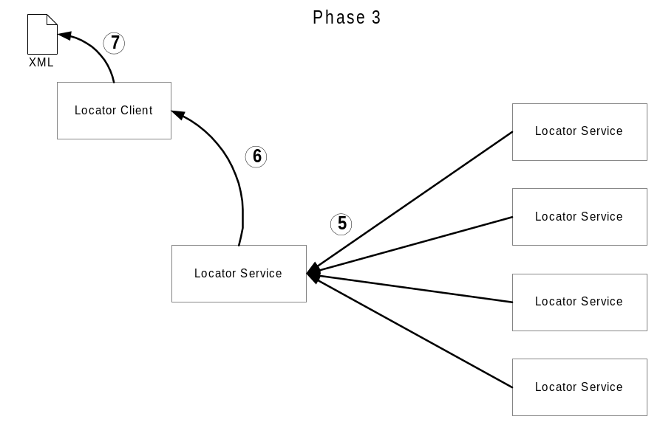Figure 6 - Phase 3 of Locator Discovery

Integration Options with Locator Service

Customer’s CDR solution integrated with CareScience Locator Service

There are three means of handling the data necessary for the “storage” and retrieval of a locator. Fundamentally, the locators are a URL comprised of a host name, a tcp/ip port, a file handler and the parameters necessary. An example might be: https://host/GetLab?clientId=x1&specId=x2&resId=x3&facId=x4&enctrClaimId=x5&xsl=/LabFrmt.xsl
This information can be created when either a new record is input into the clinical data store, or it could be calculated dynamically based in the information within the data store.
The option of pushing the data to a data store of locators requires the generation of an interface to push the required information out based on some event trigger, or the use of an agent that searches the data store looking for new records, then publishing them to the data store. This option is shown diagramatically on option C of
To dynamically calculate a locator we will need access to the data store. This can be accomplished either as a query via an HL7 QBP or QBE type of transactional query (A), or via an open API (B).
Using the JDBC/ODBC connection is probably the least desirable method for integration with a third party system. It would almost certainly require a utility to help map internal data structures.
Using the HL7 interfaces is a better option by opening a socket to the HL7 interface to the system we could send a query with a desired reponse that would return a parameter list. We would then populate a URL with the values from the parameter list. This is one recommended approach – as long as it can be done transactionally.
The other recommended method would be for us to define an interface that vendors could implement. We will then hit this interface to get the parameter values and populate the locator URL.

Customer Web Application Requirements
Each customer should supply a web enabled clinical repository. This may be supplied by CareScience or developed and/or purchased separately. The are any number of methods for implementing this web application. This system could be as simple as retrieving an html file or image file from a directory, or it could be a sophisticated application that connects to a database and returns standardized XML based documents. While CareScience attempts to promote standard methods of interchange, the locator service is designed to be integrated with any web application for the display of clinical information.

Constraints
The following constraints must currently be observed:
- One web application per system – a single web application must support each system or clinical repository.
- One locator service per system – If the customer supports more than one system or clinical repository from which to find clinical information, a locator service will be setup for each system.

Parameters Passed to Web Application
In a URL such as the following: https://host/GetLab?clientId=x1&specId=x2&resId=x3&facId=x4&enctrClaimId=x5&xsl=/LabFrmt.xsl
A number of parameters are passed to the web application. In this case a Servlet receives a patient or client identifier, a specimen id, a facility id and an ecounter claim id. These are the keys necessary to access a single lab result from this system. Other systems may require different parameters and it may be as simple as using a record identifier.

Security
It is recommended that the web application support bi-directional SSL and that the system be setup to use the most secure encryption suites. It is left to the customer to implement the security policy for the web application that meets their site’s security policy. Please review the Security section for further considerations.
The CareScience Certificate Authority can be used as a source of server and user certificates for use in these exchanges of clinical information.

Locator Service Properties File
The CareScience Locator Service can be configured in a number of different ways. Some of the decisions that need to be made include:
- The number of Locator Services that are desired for your site.
- The number of systems that each service supports.
- The URLs that are associated with your site or with individual systems
- The parameters that are associated with each URL.
- The method of integration used for connecting the locator service with your source system
- The parameters necessary to connect your chosen integration method.

Property Hierarchy
The CareScience Locator Service Properties file contains the following properties
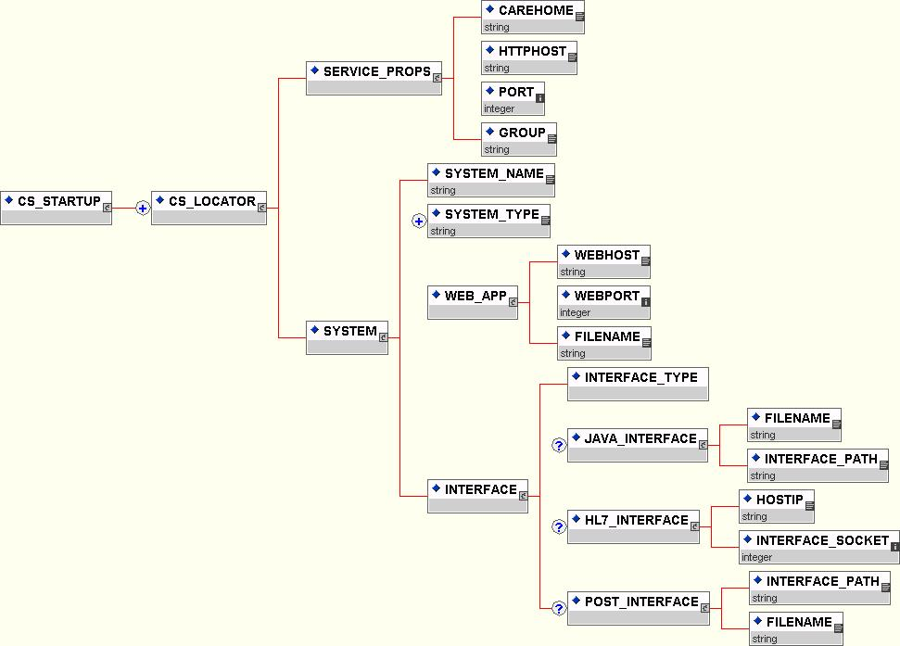
Figure 7 - Property File Hierarchy

Registering the Application System with Locator Service

<SYSTEM_NAME>CCA</SYSTEM_NAME>

Registering the type of information with the Locator Service
Tells what types of information are supported by this locator service.
<SYSTEM_TYPE>LAB</SYSTEM_TYPE>

Registering Web Applications
Registers a web server with the locator service
<WEBHOST>www.hosp.com</WEBHOST>
<WEBPORT>443</WEBPORT>
<FILENAME>getLabInfo</FILENAME>

Setting up Locator Service Operational Parameters
The group name designates the group name associated with a locator service. This should map to the organizations DNS name. Additionally, a group may be associated with specific applications or subgroups within an organization. Examples include: hospital.org, labsys.hospital.org and hospital.network.org.

<CAREHOME>com.carescience</CAREHOME>
<HTTPHOST>wwwServer</HTTPHOST>
<PORT>8081</PORT>
<GROUP>com.hosp</GROUP>

Integration Options
The Locator Service currently supports three integration options. First, a Java interface can be implemented as defined below.

Locator Service Java Interface

Description
The Locator Service can be integrated using a Java Interface implemented by the vendor or the customer. This interface is defined below in 6.1.2 Definition. The function of the interface is to return a list of parameters that must be passed to the web interface in order to calculate the URL. Input parameters will be sent from the locator service. The key/value pairs for the parameters are returned back to the locator service which will report back to the originating service. The interface returns an array of type HashMap so that the key/value pairs for each record can be returned.
The interface will receive the criteria for a query to determine what records are desired. A connection to the source database needs to be made to determine the key values that a web application can use to access the records that meet the search criteria.

Definition
package com.carescience.hils;
/**
* Title: Locator Service Project; External Locator Interface
* Description: Defines an interface to be implemented on an
* external system for integration
* with the locator service.
* Copyright: Copyright (c) 2001
* Company: CareScience, Inc.
* @version 1.0
*/
public interface ExternalLocator {
public HashMap[] getLocators(Person aPatient,
Person aProvider,
String[] infoTypes,
String[] infoClasses,
String[] encounterIDs,
Date startDateRange,
Date endDateRange) throws RemoteException;
}
The Java interface that must be implemented is defined below.
Table 1 Java Interface Definition

Registration with Properties file
The interface must be registered in the Locator Startup properties file. The following is an example of the properties file configured to use the Java Interface ().
Table 2 Java Interface Startup File
<?xml version="1.0" ?>
<CS_STARTUP>
<CS_LOCATOR>
<SERVICE_PROPS>
<CAREHOME>com.carescience</CAREHOME>
<HTTPHOST>wwwServer</HTTPHOST>
<PORT>8081</PORT>
<GROUP>com.hosp</GROUP>
</SERVICE_PROPS>
<SYSTEM>
<SYSTEM_NAME>CCA</SYSTEM_NAME>
<SYSTEM_TYPE>LAB</SYSTEM_TYPE>
<WEB_APP>
<WEBHOST>www.hosp.com</WEBHOST>
<WEBPORT>443</WEBPORT>
<FILENAME>getLabInfo</FILENAME>
</WEB_APP>
<INTERFACE>
<INTERFACE_TYPE>Java</INTERFACE_TYPE>
<JAVA_INTERFACE>
<FILENAME>LocatorImpl.jar</FILENAME>
<INTERFACE_PATH>/opt/loc/lib</INTERFACE_PATH>
</JAVA_INTERFACE>
</INTERFACE>
</SYSTEM>
</CS_LOCATOR>
</CS_STARTUP>

Locator Service HL7 Definition
If selected the HL7 interface can be utilized in a TCP/IP, sockets based approach. In this method, a QRY event will be sent to the appropriate host and socket.

QRY Format
The user is interested in finding the location of records that meet the following criteria:
- Patient ID = 123454
- Type = Lab
- Class = Chemistry
- Description = null
- Start Date Range = 12/15/2000
- End Date Range = 3/15/2001
The query is made on 3/15/2001 at 10:12 am. An immediate response is requested. The quantity limited is unspecified.
MSH|^-|&|ICU| |LAB01| | | |QRY^Q01|MSG00001|P|2.3<cr>
QRD|200103151012|D|I|4387| | | |123454|Chemistry |Lab| |ALL<cr>
QRF| |200012150000|200103151012|Chemistry;Lab| | | | |<cr>

RSP format
The Response to the above query may appear as follows:
MSH|^-|&|LAB01| |ICU| | | |DSR|ZXT23461|P|2.3<cr>
MSA|AA|MSG000001P<cr>
QRD|200103151012|D|I|4387| | | |123454|Chemistry |Lab| |ALL<cr>
DSP| | |patID=123454;recID=239482
DSP| | |patID=123454;recID=098342
DSP| | |patID=123454;recID=234255
DSP| | |patID=123454;recID=012211
DSP| | |patID=123454;recID=098234
DSP| | |patID=123454;recID=234211
DSP| | |patID=123454;recID=012098

Properties for HL7 interface
The interface properties for the HL7 interface differ from those used for the Java interface.
<?xml version="1.0" ?>
<CS_STARTUP>
<CS_LOCATOR>
<SERVICE_PROPS>
<CAREHOME>com.carescience</CAREHOME>
<HTTPHOST>wwwServer</HTTPHOST>
<PORT>8081</PORT>
<GROUP>com.hosp</GROUP>
</SERVICE_PROPS>
<SYSTEM>
<SYSTEM_NAME>CCA</SYSTEM_NAME>
<SYSTEM_TYPE>LAB</SYSTEM_TYPE>
<WEB_APP>
<WEBHOST>www.hosp.com</WEBHOST>
<WEBPORT>443</WEBPORT>
<FILENAME>getLabInfo</FILENAME>
</WEB_APP>
<INTERFACE>
<INTERFACE_TYPE>HL7</INTERFACE_TYPE>
<HL7_INTERFACE>
<HOSTIP>127.0.0.1</HOSTIP>
<INTERFACE_SOCKET>9091</INTERFACE_SOCKET>
</HL7_INTERFACE>
</INTERFACE>
</SYSTEM>
</CS_LOCATOR>
</CS_STARTUP>
Table 3 Properties for HL7 Interface

Locator Service HTTPS Post of Locator Information
This option allows an external system to post XML messages containing the Locator information to the Locator Service which then manages the storage and retrieval of this information. This option requires that the external system handle add transactions (new information), plus updates (e.g. a host name change) and deletes. This option will also require that sufficient disk space be made available to store the locator information. While each record is very small, the potential for this data to grow is very real. CareScience, has recorded average transaction volumes of approximately 8.5 million records per year per organization. This average translates into roughly .75 GB of locator per year. Actual data size may vary based on the length of the URL as well.

DTD for messages

HTTP Post of Message
The add, update, delete messages are posted to the locator service via http. The envelope for the message should include the following:
POST http://127.0.0.1:9090/path HTTP/1.0
Connection: Keep-Alive
Content-type:application/vnd.loc;version=”1.0”;charset=”UTF=8”
Content-Length:nnnn

Properties for HTTP Post Interface
The Post interface uses another set of parameters as described below.
Table 4 Properties for HL7 Interface
<?xml version="1.0" ?>
<CS_STARTUP>
<CS_LOCATOR>
<SERVICE_PROPS>
<CAREHOME>com.carescience</CAREHOME>
<HTTPHOST>wwwServer</HTTPHOST>
<PORT>8081</PORT>
<GROUP>com.hosp</GROUP>
</SERVICE_PROPS>
<SYSTEM>
<SYSTEM_NAME>CCA</SYSTEM_NAME>
<SYSTEM_TYPE>LAB</SYSTEM_TYPE>
<WEB_APP>
<WEBHOST>www.hosp.com</WEBHOST>
<WEBPORT>443</WEBPORT>
<FILENAME>getLabInfo</FILENAME>
</WEB_APP>
<INTERFACE>
<INTERFACE_TYPE>HL7</INTERFACE_TYPE>
<POST_INTERFACE>
<INTERFACE_PATH>/opt/locdata</ INTERFACE_PATH >
<FILENAME>locators</FILENAME>
</POST_INTERFACE>
</INTERFACE>
</SYSTEM>
</CS_LOCATOR>
</CS_STARTUP>

Future Options
The locator service will support additional integration options in the future. These include JNI options to integrate with systems implemented using C, C++, VisualBasic or other languages. Additionally, an RMI option will be available which will also allow integration, via RMI/IIOP, to CORBA based systems.

Locator Service Client
An available Java Client can be acquired from CareScience as part of a development SDK. This client can be used to develop web based and java based user interfaces to the locator system. This client handles the events and connectivity to the locator service as well as the marshalling of parameters for transmission to the locator service.

Properties File DTD
Table 5 - Locator Parameters DTD
<!—Copyright, 2001 CareScience, Inc. -->
<!—CS_LocParams.dtt -->
<!ELEMENT CS_LOCATOR (SERVICE_PROPS , SYSTEM)>
<!ELEMENT SYSTEM (SYSTEM_NAME , SYSTEM_TYPE+ , WEB_APP , INTERFACE)>
<!ELEMENT SYSTEM_TYPE (#PCDATA)>
<!ATTLIST SYSTEM_TYPE e-dtype NMTOKEN #FIXED 'string' >
<!ELEMENT GROUP (#PCDATA)>
<!ATTLIST GROUP e-dtype NMTOKEN #FIXED 'string' >
<!ELEMENT CAREHOME (#PCDATA)>
<!ATTLIST CAREHOME e-dtype NMTOKEN #FIXED 'string' >
<!ELEMENT HTTPHOST (#PCDATA)>
<!ATTLIST HTTPHOST e-dtype NMTOKEN #FIXED 'string' >
<!ELEMENT PORT (#PCDATA)>
<!ATTLIST PORT e-dtype NMTOKEN #FIXED 'int' >
<!ELEMENT SERVICE_PROPS (CAREHOME , HTTPHOST , PORT , GROUP)>
<!ELEMENT SYSTEM_NAME (#PCDATA)>
<!ATTLIST SYSTEM_NAME e-dtype NMTOKEN #FIXED 'string' >
<!ELEMENT WEB_APP (WEBHOST , WEBPORT , FILENAME)>
<!ELEMENT WEBHOST (#PCDATA)>
<!ATTLIST WEBHOST e-dtype NMTOKEN #FIXED 'string' >
<!ELEMENT WEBPORT (#PCDATA)>
<!ATTLIST WEBPORT e-dtype NMTOKEN #FIXED 'int' >
<!ELEMENT FILENAME (#PCDATA)>
<!ATTLIST FILENAME e-dtype NMTOKEN #FIXED 'string' >
<!ELEMENT CS_STARTUP (CS_LOCATOR+)>
<!ELEMENT INTERFACE (INTERFACE_TYPE , JAVA_INTERFACE? , HL7_INTERFACE? , POST_INTERFACE?)>
<!ELEMENT INTERFACE_PATH (#PCDATA)>
<!ATTLIST INTERFACE_PATH e-dtype NMTOKEN #FIXED 'string' >
<!ELEMENT INTERFACE_TYPE (#PCDATA)>
<!ELEMENT INTERFACE_SOCKET (#PCDATA)>
<!ATTLIST INTERFACE_SOCKET e-dtype NMTOKEN #FIXED 'int' >
<!ELEMENT JAVA_INTERFACE (FILENAME , INTERFACE_PATH)>
<!ELEMENT HL7_INTERFACE (HOSTIP , INTERFACE_SOCKET)>
<!ELEMENT POST_INTERFACE (INTERFACE_PATH , FILENAME)>
<!ELEMENT HOSTIP (#PCDATA)>
<!ATTLIST HOSTIP e-dtype NMTOKEN #FIXED 'string' >

